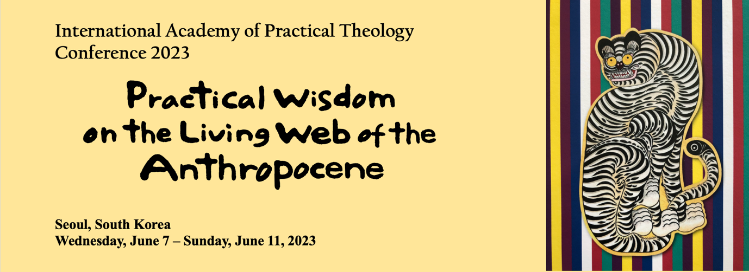

Greetings Colleagues,

In 2023, IAPT returns to East Asia after 20 some years. Coming out of the long COVID-19 social distancing, we hope to bring back our commitment to immerse ourselves in different contexts to learn from one another in our face-to-face conversations and in person immersion experiences. Marking this important transition, we invite you to come to South Korea for our biannual conference in June. We will meet on two historical campuses of Yonsei University and Ewha Womans University in the heart of Seoul from June 7 to June 11. This meeting promises to be an extraordinary one that will leave a powerful impression on your memory. Please read this newsletter to shape up your presentation and prepare for the trip. Along with this newsletter, we will keep updating the conference website on https://sites.google.com/view/iaptseoul.

Practical Wisdom on the Living Web of the Anthropocene

You are invited to reflect together in the dynamic cultural terrain of East Asia, where the intersection and interconnectedness of technology, competing political and economic dynamics, and the haunting history of colonialization and wars present endless challenges to the relationship between the human and the earth. Such interconnectedness is lived out both in positive and negative ways. While the rapid economic development is the apparent fruit of the global connectivity, our land, water, and air are also connected on a global level, letting us experience pollution that originates from all parts of the world flowing into our backyards. The phenomena of sharing pollution led those living in these regions to wear masks daily even before COVID-19 struck the world. The definite mark that humankind is leaving on the earth is undeniably visible on this land.

Korea is often cast in the light of the tragedy of the Cold War and colonization, with our Northern half still alerting the international communities with their political actions. However, such past tragedies are not the center of our lived experience on the ground. They may haunt the present, giving it some color, but today’s daily challenges lie in the rapidly developing technological world that both build and break down the relationships between humans and earth. The advancement of technology seems unstoppable despite the urgent calls from the scientific communities to protect our world from imminent environmental doom. The community that drives technological development has its own impulse for curiosity and problem-solving, which are intricately and organically intertwined with the neoliberal rationality that defies the collaboration of the political will to create ethical actions for the common good. Such intersection of technological, economic, and political worlds has created many meta-narratives that compete for our attention in particular ways, seemingly defusing the collective wills to respond to the urgency of the environmental crisis we face. It seems practical theology should find its role to address such a challenge.

In this conference, we call on the practical wisdom of practical theologians working in the trenches of various fields. Why have we not been able to work together to save our common home, the earth? When we did work together, what worked? What did not work? What do we understand about the dynamics of these intersections? How do they shed light on the future of our global community? In asking these questions, our choice of the phrase ‘practical wisdom’ is intentional. If not to address Don Browning’s foundational insight to bring the practical philosophy of phronesis to locate the interpretive process in practice and doing, we would take a step further to call on sources of practical theology beyond the bound of the West– and logos-centered theological traditions. In reconnecting the relationship between the earth and the human, can we find different frameworks in traditions of diverse localities to build practical theology?

Practical theologians have long understood the interconnectedness of our realities. In the beloved metaphor of the living human web, plucking on one thread of the web should deliver the ping over the whole web. Such connection could also be very messy: the web may have many entangled knots that need examination and delicate untangling. The practical wisdom we find in our communities invites us to reflect on the resonating impact of various practical wisdoms stemming from the experiences of different sectors. What does the experience in one end of the connection say about the experience of the other end? What can we say about the state or quality of our interconnectedness? How does justice prevail in such interconnections? Pondering about such interconnection, can we find a better way to meet the impending doom/challenges in a more hopeful way? How do we generate eschatological practical wisdom in our local and global communities?

Our plenary speakers will address following subtopics that will allow us to engage the conference theme in layers and depth. We are proud to present to you the following keynote speakers:

Keynote 1: Practical Theology of Anthropocene: Ryan LaMothe

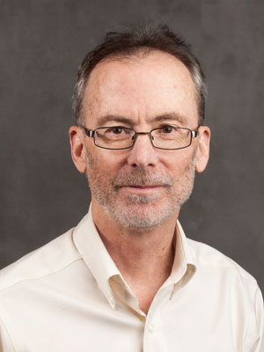
Ryan LaMothe is a professor of pastoral care and counseling at Stain Meinrad Seminary and School of Theology. He is past president of Society for Pastoral Theology. Over the past 26 years he has published over 190 articles and 10 books. In 2017 Ryan received the Springer Publishing Award (Transforming the World One Article at a Time). His most recent book is A Radical Political Theology for the Anthropocene Age (2021). Later this year Lexington Press will publish another of Ryan’s books— Pastoral Care in the Anthropocene Age: Facing a Dire Future Now.

Keynote 2: Eschatological Practical Theology: Elaine Graham

Educated at the Universities of Bristol and Manchester, Elaine Graham was Grosvenor Research Professor of Practical Theology at the University of Chester from 2009 until her retirement in July 2021. She now holds the title of Professor Emerita. Between 1998-2009 she was Samuel Ferguson Professor of Social and Pastoral Theology at the University of Manchester. She is the author of several major books, including Transforming Practice (1996), Representations of the Post-Human (2002) and Words Made Flesh (2009); with Heather Walton and Frances Ward, Theological Reflection: Methods (2nd Edition, 2019); and with Zoe Bennett, Stephen Pattison and Heather Walton, Invitation to Practical Theology Research (Routledge, 2018). Her most recent work considers public theology as a form of Christian apologetics: Between a Rock and a Hard Place: Public Theology in a Post-Secular Age (2013) and Apologetics without Apology: speaking of God in a world troubled by religion (Cascade, 2017). She was President of the International Academy of Practical Theology between 2005-2007. In July 2021 she was elected a Fellow of the British Academy.
Her current research interests include an examination of the life, thought and legacy of the Cambridge philosopher and theologian Don Cupitt, as well as continued interest in public theology and post-secularity.
Keynote 3: Economic and Political Concerns of the Anthropocene: Hee-Kyu Heidi Park

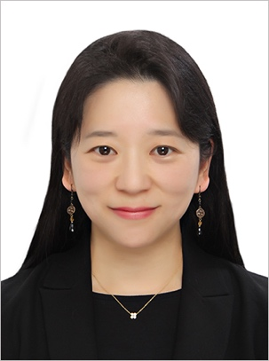
Hee-Kyu Heidi Park is an assistant professor of Practical Theology and Pastoral Counseling in the Christian Studies Department at Ewha Womans University in Seoul, South Korea. Before Ewha, she was an assistant professor of pastoral theology at Xavier University in Cincinnati, OH. She also taught at her alma mater, Claremont School of Theology and Lexington Theological Seminary as an instructor.
Her current research focuses on practical theological methodology of boundary experiences. Through a series of qualitative studies on Korean and Korean American experiences complexified by the colonization, the Cold War, and the rapid embracement of neoliberalism, her research investigates the collective trauma and spirituality resulting from these social dynamics. The postcolonial concept of spectrality plays a crucial role, both as a foundational for her research methodology as well as a descriptive concept of her work.
She is currently serving as the vice-chair in the steering committee of the Society for Pastoral Theology, and a member of the steering committee of Practical Theology Unit of AAR. At IAPT, she is serving as a member of the local and executive committee.

Round Table: Peace/War/Unity and the Anthropocene: Roundtable Discussion by Joung Chul Lee (moderator), Keun-Joo Christine Pae, Maira Hayat, Ayoung Moon, and Andreas Hasenclever
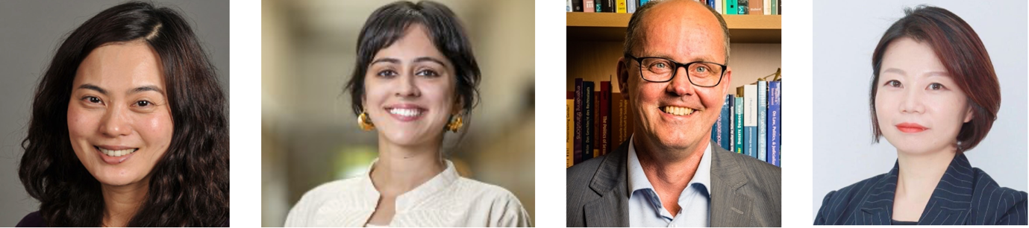

The Rev. Dr. Keun-Joo Christine Pae is Associate Professor of Religion/Ethics and Women’s and Gender Studies, and Chair of the Department of Religion. Her research and teaching interests include transnational feminist ethics, religious ethics of peace and war, feminist spiritual activism, and Asian/Asian American feminist theologies and ethics. She is currently co-editing, Embodying Antiracist Christianity: Asian American Feminist Theologies for Just Racial Relations (Palgrave) and writing two monographs, Doing Feminist Ethics Transnationally, and Bodies of War. Dr. Pae is also secretary of Pacific Asian North Asian American Women in Theology and Ministry, co-chair of the American Academy of Religion’s Women and Religion Unit, and member of the Status of Women in the Professor Committee of the AAR.

Maira Hayat is a concurrent faculty member in Notre Dame’s Department of Anthropology. Before coming to Notre Dame, she was a postdoctoral fellow in Stanford University’s Department of Anthropology and at the Woods Institute for the Environment. She earned a PhD from the Department of Anthropology at the University of Chicago in December 2018. Hayat graduated from the Lahore University of Management Sciences in Pakistan in 2008 and holds an MSc in social anthropology from the University of Oxford. Hayat conducts research at the intersection of bureaucracy, law, and the environment, drawing on ethnographic and archival methods. Her current and first book project is based on her doctoral dissertation, “Ecologies of Water Governance in Pakistan: The Colony, the Corporation and the Contemporary,” which won the 2019 S.S. Pirzada Annual Dissertation Prize for best dissertation on Pakistan. A dissertation chapter, “The Gender of Corruption: Bureaucrats, Bodies, and the Female Complaint in an Irrigation Bureaucracy,” won the Association for Feminist Anthropology’s 2018 Sylvia Forman Prize for Outstanding Graduate Paper. Hayat’s work has been supported by the Wenner-Gren Foundation, the National Science Foundation, and the American Institute of Pakistan Studies. Her publications, including a special issue she co-organized, have appeared in the Anthropology of Work Review, Critique of Anthropology, and Journal of the Anthropological Society of Oxford among others. Hayat’s community-engaged teaching on environmental violence and justice has been awarded a Cardinal Course Grant Award for Public Service and an arts Catalyst Grant (at Stanford University) and a Starr Lectureship Award at the University of Chicago.

Andreas Hasenclever is Professor of International Relations and Peace Studies at the University of Tübingen, Germany. He studied political science and roman catholic theology in Tübingen, Munich and Paris. In 2000, he received his Ph.D. from the University of Tübingen with a dissertation on “The Power of Morality in International Relations. Analyzing Military Interventions of Western States in Somalia, Rwanda and Bosnia”. The dissertation was awarded the Helmuth-James-von-Moltke Prize 2003 of the German Society for Military Law and International Humanitarian Law. His major research interests are in the field of Peace and Conflict studies with particular reference to regime analysis, international trust dynamics, and the impact of religious traditions on political conflicts. Among his most important publications are “Theories of International Regimes” published with Cambridge University and “Does Religion Make a Difference? Theoretical Approaches to the Impact of Faith on Political Conflict” which he contributed to Millennium – Journal of International Studies. Andreas Hasenclever co-edited special issues with Civil Wars (2015) on “Framing Political Violence – A Micro-Approach to Civil War Studies” and with Third World Thematics (2018) on “Affectedness in Global Governance and International Law”. Moreover, he published various papers on the conceptualization of collective trust dynamics in international affairs and the role of religion in armed conflicts. Andreas Hasenclever currently serves as director of the Institute of Political Science and is elected member of the senate of the University of Tübingen.

Ayoung Moon is a founder and representative of PEACEMOMO, a non-profit, education specialist organization since 2012. PEACEMOMO translates the language of peace activism into the public education curriculum in order to flatten peace activism to be the default for all. PEACMOMO highlights creating non-teaching, mutually dialogical relations in learning sites and runs regular ToT (training of trainers) programs to foster transformative peace educators. She regularly conducts training, develops training manuals, and joins regional and local forums for peace activism and education. Currently, she is a Ph.D. candidate in Peace Education at the UN-mandated University for Peace (UPEACE) in Costa Rica, a council member of the International Peace Bureau (IPB), and an adjunct professor at the Department of International Development Cooperation and North Korea Studies at Seoul Cyber University. She is also an advisor to various institutes related to peace and education such as the Ministry of Education, Ministry of Unification, and Ministry of Gender Equality and Family of the Republic of Korea.

Keynote 4: Practical Wisdom from Diverse Traditions Addressing the Challenges of the Anthropocene: Mary Elizabeth Moore

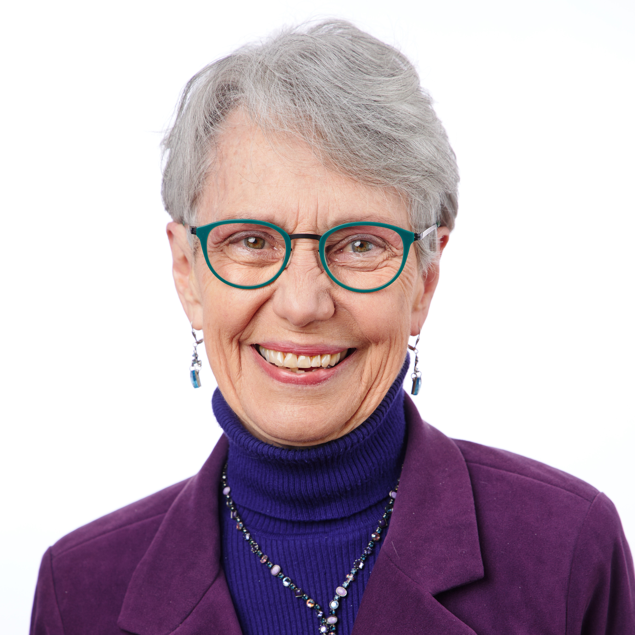
Mary Elizabeth Moore is Dean Emerita and Professor Emerita of Theology and Education, Boston University School of Theology. Her current research focuses on the integral relationship of sacrality and tikkun olam, or repair of the world, through the study of ecological and justice practices and the theological and existential issues underlying them. As a practical theologian, she draws on research into the practices, theories, and poetics of cultural and racial diversity, ecological justice, interreligious relationships, liberative theologies, education, leadership, peacemaking, white privilege, gender/sexuality, and healing/social transformation. Her recent book publications include Teaching as a Sacramental Act and the editing or co-editing of Deep Understanding for Divisive Times; A Living Tradition: Critical Recovery and Reconstruction of Wesleyan Heritage; and Children, Youth, and Spirituality in a Troubling World. Her recent articles include “Responding to a Weeping Planet: Practical Theology as a Discipline Called by Crisis”; “The Hidden Force of Gender and Sexuality: A Pedagogy of Truth-Seeking”; “Embracing Sexuality and Gender: Toward Radical Love”; “Sacred, Revolutionary Teaching: Encountering Sacred Difference and Honest Hope”; “Disrupting White Privilege: Diving beneath Shame and Guilt”; “Encountering Dignity: Building Human Community”; and “Deep Breathing in a Moving World.” She also enjoys the delight of writing poetry.

Keynote 5: Technology and Environment: Zach Walsh and Chammah Kaunda

Zack Walsh, Ph.D. is an Independent Researcher and Consultant who provides strategic foresight to organizations negotiating the transition to an equitable, post-carbon, post-growth world. He completed his doctorate in Process Studies at Claremont School of Theology. He holds an M.A. in Buddhist Studies from Foguang University, Taiwan and a B.A. in East Asian Studies from Denison University. He has recently worked with the One Project, Post Carbon Institute, Institute for Advanced Sustainability Studies, Institute for Ecological Civilization, and the Courage of Care Coalition. His publications explore the intersections between social justice, eco-justice, and systems change with a focus on post-capitalism and the commons.

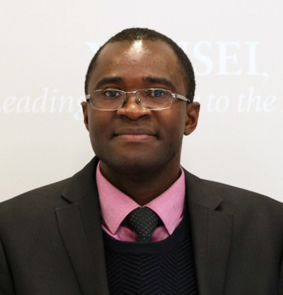
Chammah J. Kaunda is a Zambian scholar currently working as an Assistant Professor of World Christianity and Mission Studies at the United Graduate School of Theology, Yonsei University, Republic of Korea. He is also an Extraordinary Professor in the Department of Religion and Theology at the University of the Western Cape, South Africa. His current research interests focus on Pentecostalisticity, decoloniality, poetics of mysticality and materiality, and the intellectual history of African theological ideas. Kaunda draws on various theoretical approaches including critical Africana theories, African philosophy and theology, decolonial theology, black liberation theology, missiology, ecumenism anthropology, political, gender and ecological theologies. He has authored over 100 and still counting peer-reviewed journal articles and book chapters in internationally renowned journals and book publishers. He also co/edited over 6 volumes, authored 1 book and co-authored 1 book. He has been a guest editor for various academic journals. In 2018 he was recognized in the list of the top 10 young most published researchers under 40 at the University of KwaZulu-Natal. His recent co/edited include World Christianity and COVID-19: Looking Back and Looking Forward (Springer, 2022 – forthcoming); Christianity and COVID-19: Pathways for Faith (Routledge, 2021); Genders, Sexualities, and Spiritualities in African Pentecostalism: 'Your Body is a Temple of the Holy Spirit' (Palgrave Macmillan, 2020); African Theology, Philosophy, and Religions: Celebrating John Samuel Mbiti’s Contribution (Lexington Books, 2020).

The paper sections of the conference will be divided according to the following sub-themes. Please submit your abstract (Please include the title, the sub-theme, your membership status, affiliation and contact information) to the following email address by October 1, 2022. We will review the submissions continuously as we receive them: iapt.seoul@gmail.com.

1. Economic and Political Concerns of the Anthropocene
Our global community is tasked to manage the “common pool resources (CPRs)’ or commons, namely the resources common and open to all on the planet earth and from which exclusion of individual is not possible, including fisheries, backwoods, groundwater bowls, pastures, lakes, seas, and earth's climate. This topic explores how we as practical theologians carry out this task. How does the environmental crisis interconnect with the politico-economic reality of our society? Where and how is the margin created? Or where and how are the environmental precariats/NEETs/Freeters generated? How do we as practical theologians understand and create room for political/economic justice in the rapidly changing trajectories of climate change? In light of the changes in the ecological spaces of our common home, the earth, what are the dynamics observable in the rise and fall of human freedom and human right in their various contexts? How do we generate practical wisdom and strategies for practice in such a socio-economical context as practical theologians? How does the church respond?

2. Peace/War/Unity and the Anthropocene
As IAPT 2023 is held in South Korea, a country scarred by the Cold War and continues to live it as her reality, we inquire the possibility of unity and peace, even as we move deeper into the new era that will be marked with environmental challenges. We also recognize newly erupting wars, coups, and rise of military power in different parts of the world, which are connected to environmental factors both in the most obvious and covert ways. For example, in South Korea, as the U.S. military bases move out of the localities they occupied since the Korean War, the sites reveal severe pollution primarily caused by military machinery and weapons. At the same time, the DMZ between North and South Korea preserves biodiversity in ways that no other places have. Communities in such places have the task of reckoning with the past historical trauma to build peace and unity, which requires dealing with the aftermath of the past in the context of environmental disaster or paradise. When desertification drove those from formerly agricultural areas to cities, tensions grew among the over-populated urban communities; some trace the genesis of the long-lasting Syrian war from such environmental disaster. How do communities, secular, religious, and interreligious, engage the challenges of such calamities? What are the theological angles from which to reflect on those experiences? We ask practical theologians to excavate the interconnectedness of human communities and ecological changes. Where do you see the communal efforts to create restorative, non-violent solutions to engage such interconnectedness? How do practical theologians understand the practical wisdom that is generated from such efforts?

3. Technology and Environment (AI)
Anthropocenic humans have created a world in which God's creatures compete with human creations for limited resources that our planet can offer. In our rapidly digitizing world, travel to Mars and self-driving cars are already a reality, while the scope of the concept of space gradually turns boundless with the development of virtual reality. Technology advances on its own terms is fueled by neoliberal impulses, while human subjectivity is getting coded and mechanized in the form of AI and virtual reality. Nevertheless, engaging such aspect of human life has been limited in the field of practical theology. What are the theological paradigms and strategies that our practical wisdom can generate to enable the most ecological and sustainable technological development in the given order of the neoliberal world? Or can we create an alternative to the neoliberal world that has the space for just relations among living things, human creations, and the earth? How do we understand God and humans in the age of artificial intelligence and deep learning? What are the stem cells, growth points, blind spots, and black holes of our technological world that practical theologians should be aware of to generate sustainable human flourishing and equity? What does the practical theology of technology look like in the Anthropocene/Capitalocene?

4. Eschatological Practical theology on Disaster and Hope
With the so-called carbon clock clicking (https://www.mcc-berlin.net/fileadmin/data/clock/carbon_clock.htm) and science communities warning us with scenarios of climate disasters, practical theologians face the prophetic task of preparing for the upcoming disaster much like the task given to prophet Jeremiah in the Hebrew Bible. Here we face a question of our practical theological orientation. Practical theology is oftentimes understood as the exegesis of the lived experience. These experiences are understood to be lived in the present or the past. Can we exegete the future, the imagined conjecture, the experience to be lived? What does such practical theology look like? What will such practical theology accomplish? What is the task of such eschatological practical theology? Lament? Healing? Goodbyes? The imagination of im/possibilities? How do the sub-disciplines of practical theology engage such tasks of eschatological practical theology?

5. Practical Theology Reconsidered: Practical Wisdom from Diverse Traditions Addressing the Challenges of the Anthropocene

Under this theme, we provide opportunities to work on the prolegomena of a practical theology of the Anthropocene, addressing the bigger questions we raised in our rationale of this conference. In such an effort, we see the possibility of engaging diverse traditions to find practical wisdom to find global theological solutions to our ecological challenges. What are the resources that global communities can benefit from? We seek practical theological engagement of wisdom in Asia, Africa, Australia, and the Americas, focusing on perspectives from the global south.

6. Faith Communities in the Rapidly Changing World of the Anthropocene

In various subfields of practical theology, what are the challenges that churches/faith communities encounter? After the rapid growth in the 20th century, Korean protestant churches are facing a decline, which was exacerbated with the challenges of COVID-19. The generation of millennials and Generation Z, often affected by both eco-anxiety and social insecurity stemming from the plateauing of economic development, show a definite skew toward secularization. In contrast, the older generation is hyper-activated with political zeal toward conservatism. The technological advancement and the growth of civic awareness under the neoliberal paradigm also form the new spiritual environment of contemporary Korean society. From our reflection on such context, we bring this question about the challenges that the rapidly changing world poses on the faith communities. We ask practical theologians to reflect on the trajectories of faith communities’ ministry and the existential challenges of the religious institution in their contexts. Such reflection could come from innovative steps that faith communities have taken to deal with their challenges. How do they manifest? How are they related to the bigger picture of the challenges of the Anthropocene and Capitalocene? What are the challenges of the future of the faith community and its ministry? How do we navigate through them? How do practical theologians respond to the challenges manifesting in their fields? We hope to summon the voices from the ground where practical wisdom is unfolding to confront such challenges.

As we continue to shape up the conference, more concrete information will be shared through our subsequent newsletters. In the meanwhile, if you have any question, please contact Heidi Park at heekyu.park@ewha.ac.kr. We hope to see you all in Seoul!

Local Committee: Soo-Young Kwon (Yonsei University), Hee-Kyu Heidi Park (Ewha Womans University), Hyun-Sook Kim (Yonsei University), Yunsoo Joo (Busan Presbyterian University), Joung Chul Lee (Kookmin University)

Not in education, employment, or training.
A Japanese term for those who are unemployed. Thought to be a combination of the English word free and the German word Arbeiter.

